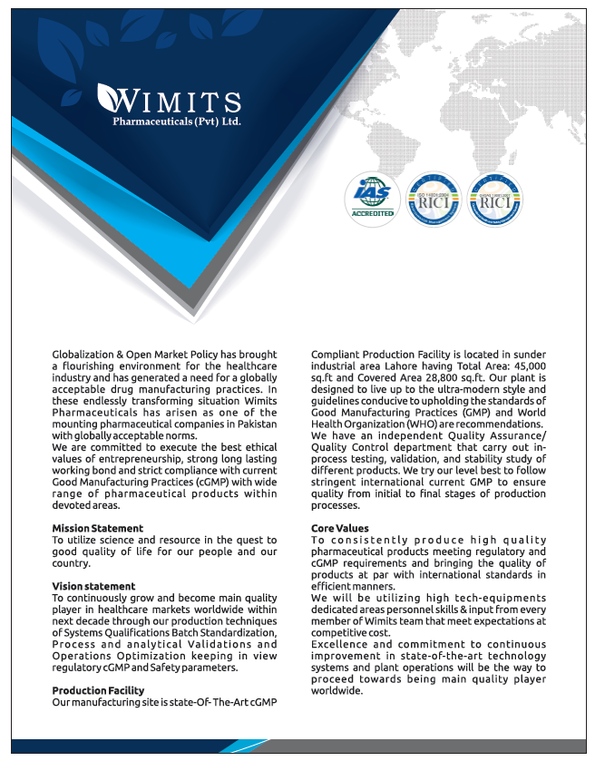

ABOUT US
Name of the Manufacturer | Wimits Pharmaceuticals (Pvt.) Ltd.
Address | Plot No. 129 – Sunder Industrial Estate Raiwind Road, Lahore, Pakistan
Drug Manufacturing License No. | 000789
CONTACT US
Email: | export@wimits.com
UAN: | +92-42 111 11 6366
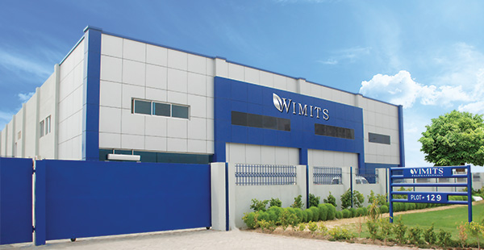
PRODUCT LIST
TABLETS
Reg. # | Category | Product Name | Composition | Pack Size
077222 | Tablet | Fenbid | Each film coated tablet contains:  Flurbiprofen…100mg  (BP Specs) | 30's
077264 | Tablet | Levodor 250mg | Each film coated tablet contains:  Levofloxacin as Hemihydrate........250mg  (Wimits Specs) | 10's
077265 | Tablet | Levodor 500mg | Each film coated tablet contains:  Levofloxacin as Hemihydrate …...500mg  (Wimits Specs) | 10's
077266 | Tablet | Monadol | Each film coated tablet contains:  Paracetamol………………..500mg  Caffeine……………………..65mg  Chlorpheniramine Maleate...2mg  (Wimits Specs) | 100's
077263 | Tablet | Solo-Cip 250mg | Each film coated tablet contains:  Ciprofloxacin HCl ………….250mg  (USP Specs) | 10's
077262 | Tablet | Solo-Cip 500mg | Each film coated tablet contains:  Ciprofloxacin HCl …………..500mg  (USP Specs) | 10's
078682 | Tablet | Levic 250mg | Each film coated tablet contains:  Levetiracetam………………..250mg  (USP Specs) | 30's
078683 | Tablet | Levic 500mg | Each film coated tablet contains:  Levetiracetam ………………500mg  (USP Specs) | 30's
078676 | Tablet | Macral 250mg | Each film coated tablet contains:  Clarithromycin……………….250mg  (USP Specs) | 10's
086280 | Tablet | Macral 500mg | Each film coated tablet contains:  Clarithromycin………………..500mg  (USP Specs) | 10’s
078687 | Tablet | Desotin | Each film coated tablet contains:  Desloratadine ………………..5mg  (Wimits Specs) | 10's
084857 | Tablet | Diva 500mg | Each enteric coated tablet contains:  Divalproex Sodium Equivalent to Valproic Acid …………500mg  (USP Specs) | 100's
084858 | Tablet | Diva 250mg | Each enteric coated tablet contains:  Divalproex Sodium Equivalent to Valproic Acid ………….250mg  (USP Specs) | 100's
084859 | Tablet | ES'LA | Each tablet contains:  Escitalopram as oxalate ……...20mg  (USP Specs) | 14's
084860 | Tablet | Moxi'la | Each tablet contains:  Moxifloxacin hydrochloride …..400mg  (As per Innovator's Specification) | 5's
084861 | Tablet | Artemet | Each tablet contains:  Artemether …………………….40mg  Lumefantrine ………………….240mg  (International Ph. Specification) | 10's
085806 | Tablet | Wimlox | Each tablet contains:  Artemether …………………….20mg  Lumefantrine ………………….120mg  (International Ph. Specification) | 16’s
084665 | Tablet | Cetrido | Each film coated tablet contains:  Cetrizine dihydrochloride ….10mg  (As per Innovator's Specification) | 10's
006248-EX | Tablet | Rosuwim 20mg | Each film coated tablet contains:  Rosuvastatin (as calcium)……20mg | As per requirement
006815-EX | Tablet | Rosuwin 10mg | Each film coated tablet contains:  Rosuvastatin (as calcium)……10mg | As per requirement
006251-EX | Tablet | Novirtab | Each tablet contains:  Sofosbuvir…….400mg  Ledipasvir…….90mg | As per requirement
085792 | Tablet | Bene | Each film coated tablet contains:  Piroxicam (as Betacyclodextrin ….… 20mg  (As per Innovator's Specification) | 20’s
085808 | Tablet | Wimzole | Each film coated tablet contains:  Letrozole …...………..2.5mg  (USP Specifications) | 10’s
085794 | Tablet | Xantix | Each film coated tablet contains:  Tizanidine HCl …...….2mg  (USP Specifications) | 10’s
090107 | Tablet | Sitacor Plus | Each film coated tablet contains:  Sitagliptin …………….50mg  Metformin HCl…..........500mg | 14’s
090108 | Tablet | Sitacor Plus | Each film coated tablet contains:  Sitagliptin ……….. 50mg  Metformin HCl…... 1gm | 14’s
085784 | Tablet | Viline-Met 50/850mg | Each film coated tablet contains:  Vildagliptin ……….. 50mg  Metformin HCl…......850mg  (as per innovator’s specifications) | 28’s
085783 | Tablet | Viline-Met 50/1000mg | Each film coated tablet contains:  Vildagliptin ……….. 50mg  Metformin HCl…......1gm  (as per innovator’s specifications) | 28’s
085781 | Tablet | Wascorel 75mg | Each film coated tablet contains:  Clopidogrel (as bisulfate)……….. 75mg  (USP Specifications) | 10’s
085780 | Tablet | Wascorel 300mg | Each film coated tablet contains:  Clopidogrel (as bisulfate)……….. 300mg  (USP Specifications) | 10’s
085782 | Tablet | Wascorel-S | Each film coated tablet contains:  Clopidogrel (as bisulfate)……….. 75mg  Aspirin………..…......75mg  (as per innovator’s specifications) | 10’s
085804 | Tablet | Lintex | Each film coated tablet contains:  Sertraline Hydrochloride ……. 100mg  (USP Specifications) | 20’s
085799 | Tablet | Copsid | Each tablet contains:  Paracetamol …………………...325mg  Tramadol Hydrochloride ……..37.5mg  (USP Specifications) | 10’s
085789 | Tablet | Dilozen 400mg | Each film coated tablet contains:  Linezolid ……….. 400mg  (as per innovator’s specifications) | 12’s
085790 | Tablet | Dilozen 600mg | Each film coated tablet contains:  Linezolid ……….. 600mg  (as per innovator’s specifications) | 12’s
085795 | Tablet | L-Nox 4mg | Each film coated tablet contains:  Lornoxicam ……….. 4mg  (as per innovator’s specifications) | 10’s
085796 | Tablet | L-Nox 8mg | Each film coated tablet contains:  Lornoxicam ……….. 8mg  (as per innovator’s specifications) | 10’s
085787 | Tablet | Xibu 200mg | Each film coated tablet contains:  Dexibuprofen ……….. 200mg  (as per innovator’s specification) | 30’s
085786 | Tablet | Xibu 300mg | Each film coated tablet contains:  Dexibuprofen ……….. 300mg  (as per innovator’s specification) | 30’s
085788 | Tablet | Xibu 400mg | Each film coated tablet contains:  Dexibuprofen ……….. 400mg  (as per innovator’s specification) | 30’s
085785 | Tablet | Throtel | Each film coated tablet contains:  Telithromycin ……….. 400mg  (as per innovator’s specifications) | 10’s
086283 | Tablet | Lakill 100mg | Each film coated tablet contains:  Lacosamide………….100mg  (as per innovator’s specifications) | 14’s
086284 | Tablet | Lakill 50mg | Each film coated tablet contains:  Lacosamide………….50mg  (as per innovator’s specifications) | 14’s
086277 | Tablet | Askat 5mg | Each chewable tablet contains:  Montelukast (as sodium)……5mg  (USP Specifications) | 14’s
088742 | Tablet | Askat 10mg | Each film coated tablet contains:  Montelukast (as sodium)……10mg  (USP Specifications) | 14’s
086278 | Tablet | Febustat 120mg | Each film coated tablet contains:  Febuxostat……..120mg  (as per innovator’s specifications) | 30’s
086279 | Tablet | Febustat 80mg | Each film coated tablet contains:  Febuxostat……..80mg  (as per innovator’s specifications) | 30’s
088743 | Tablet | Febustat 40mg | Each film coated tablet contains:  Febuxostat……..40mg  (as per innovator’s specifications) | 20’s
086281 | Tablet | Xibmed | Each film coated tablet contains:  Etoricoxib……….60mg  (USP Specifications) | 10’s
086282 | Tablet | Wimcin | Each film coated tablet contains:  Gemifloxacin (as mesylate)…….320mg  (USP Specifications) | 7’s
085807 | Tablet | Ofax | Each film coated tablet contains:  Ofloxacin………….200mg  (USP Specifications) | 10’s
085805 | Tablet | P-Malt | Each tablet contains:  Iron (III) hydroxide polymaltose complex equivalent to elemental iron…..100mg  Folic Acid……………………….0.35mg  (as per innovator’s specifications) | 10’s
085770 | Tablet | Famitol | Each film coated tablet contains:  Famotidine …….. 40mg  (BP Specification) | 10’s

CAPSULE
Reg. # | Category | Product Name | Composition | Pack Size
006249-EX | Capsule | Flucowim | Each capsule contains:  Fluconazole……..150mg | As per requirement
077267 | Capsule | Microdox | Each capsule contains:  Doxycycline Hyclate eq. to Doxycycline ………100mg  (USP Specs) | 100's
077272 | Capsule | Oray 20mg | Each capsule contains:  Omeprazole …….20mg  (USP Specs) | 14's
078730 | Capsule | Oray 40mg | Each capsule contains:  Omeprazole ……..40mg  (USP Specs) | 14's
077273 | Capsule | Aldis 20mg | Each capsule contains:  Esomeprazole …..20mg  (Wimits Specs) | 14's
078731 | Capsule | Aldis 40mg | Each capsule contains:  Esomeprazole Magnesium Trihydrate eq. to Esomeprazole  (as enteric coated pellets)………40mg  (Wimits Specs) | 14's
078678 | Capsule | Ebalin 150mg | Each capsule contains:  Pregabalin ……..150mg  (Wimits Specs) | 14's
086276 | Capsule | Ebalin 100mg | Each capsule contains: Pregabalin………….100mg  (as per innovator’s specifications) | 14's
086275 | Capsule | Ebalin 75mg | Each capsule contains: Pregabalin………….75mg  (as per innovator’s specifications) | 14's
088739 | Capsule | Ebalin 50mg | Each capsule contains: Pregabalin………….50mg  (as per innovator’s specifications) | 14's
078677 | Capsule | Azidor | Each capsule contains:  Azithromycin dihydrate equivalent to Azithromycin ……..250mg  (USP Specs) | 10's
078733 | Capsule | APPO | Each capsule contains:  Duloxetin HCl as Enteric Coated Pellets ……………..30mg  (USP Specs) | 10's
078732 | Capsule | Diclowim Plus SR | Each capsule contains:  Diclofenac Sodium as Enteric Coated Pellets ………………100mg  (Wimits Specs) | 10's
085769 | Capsule | Tranza | Each capsule contains:  Tranexamic Acid ….. 250mg  (JP Specs) | 100’s
088740 | Capsule | Cewim 200mg | Each capsule contains:  Celecoxib ………200mg  (as per innovator’s specifications) | 10’s
088741 | Capsule | Cewim 100mg | Each capsule contains:  Celecoxib ………100mg  (as per innovator’s specifications) | 4x5’s
085802 | Capsule | Gabal 75mg | Each capsule contains:  Pregabalin ……….75mg  (As per innovator’s specifications) | 14’s

INJECTION
Reg. # | Category | Product Name | Composition | Pack Size
077219 | Injectable | Cal-Dee | Each 1ml amp contains:  Cholecalciferol (Vit D3) …..5mg  (USP Specs) | 1x1ml
077269 | Injectable | Painsa | Each 3ml ampoule contains:  Diclofenac Sodium ………..75mg  (Wimits Specs) | 5x3ml
077220 | Injectable | Art-One | Each 1ml amp contains:  Artemether …………………80mg  (Wimits Specs) | 6x1ml
078685 | Injectable | Mecowim | Each 1ml amp contains:  Mecobalamin ……………….500mcg  (Wimits Specs) | 10 x 1ml
078686 | Injectable | Epicare | Each 5ml amp contains:  Iron Sucrose Elemental Iron…..100mg  (USP Specs) | 5's x 5ml
078679 | Injectable | Nal-Bee | Each 1ml amp contains:  Nalbuphine HCl ……….10mg  (Wimits Specs) | 10 x 1ml
085800 | Injectable | Wimgesic | Each 1ml amp contains:  Nalbuphine HCl ……......20mg  (as per innovator’s specifications) | 10 x 1ml
078680 | Injectable | Diclowim | Each 2ml amp contains:  Diclofenac Sodium ……75mg  Lignocaine HCl ………..20mg  (Wimits Specs) | 5's
078681 | Injectable | K-Lac | Each 1ml amp contains:  Ketorolac Trometamol….30mg  (USP Specs) | 5's x 1ml
084855 | Injectable | Mavinate | Each 1ml contains:  Dimenhydrinate ………..50mg  (USP Specs) | 25 x 1ml
081275 | Injectable | W-Dol | Each 2ml ampoule contains:  Tramadol HCL….100mg  (Manufacturer's Specs) | 5's
081276 | Injectable | Ketomit | Each ml ampoule contains:  Ketorolac Tromethamine ….30mg  (USP Specs) | 5's x 1ml
085112 | Injectable | Ketwim | Each 5ml contains:  Ketamine as hydrochloride….250mg  (USP Specs) | 5ml x 5's
084666 | Injectable | Xamic | Each 5ml contains:  Tranexamic Acid……...500mg  (BP Specs) | 5ml x 10's
006250-EX | Injectable | Wi-Bion | Each 3ml ampoule contains:  Thiamine HCl (Vitamin B1)…100mg  Pyridoxine HCl (Vitamin B6)….100mg  Cyanocobalamin (Vitamin B12)….1000mcg | 3ml x 25’s
085801 | Injectable | Pivacan | Each ml contains:  Bupivacaine hydrochloride……...5mg  (USP Specs) | 5’s
085803 | Injectable | Colicit | Each 2ml contains:  Citicoline as Citicoline sodium………250mg  (as per innovator’s specifications) | 2ml x 1s
085791 | Injectable | Dreetay | Each 2ml amp. contains:  Furosemide...….20mg  (USP Specifications) | 2ml x 50’s
085793 | Injectable | Myatra | Each ml Contains:  Atracurium Besylate…..10mg  (USP Specifications) | 2.5ml x 5s
085797 | Injectable | Dopa | Each ml Contains:  Dopamine HCl…..40mg  (USP Specifications) | 5ml x 1s
Awaiting Reg. | Injectable | Actopil | Each 5ml Contains:  Piracetam………..1gm | 5ml x 12’s

SYRUP / SUSPENSION
Reg. # | Category | Product Name | Composition | Pack Size
084856 | Oral Liquid | Diva Syrup | Each 5ml contains:  Divalproex sodium equivalent to valproic acid………..250mg  (As per Innovator's Specification) | 60ml
077221 | Oral Liquid | Donits Suspension | Each 1ml contains:  Domperidone …….. 1mg  (Wimits Specs) | 120ml
077270 | Oral Liquid | Ibuprofen Suspension | Each 5ml contains:  Ibuprofen…………….100mg  (BP Specs) | 90ml
077271 | Oral Liquid | Malt-Blue Syrup | Each 15ml contains:  Iron Protein Succinylate (800mg) Eq to Elemental Iron …..40mg  (Wimits Specs) | 60ml
077268 | Oral Liquid | P-Malt Syrup | Each 5ml contains:  Iron III Hydroxide Polymaltose Complex Eq to Elemental Iron….50mg  (Wimits Specs) | 60ml
078684 | Oral Liquid | Levic Oral Solution | Each 1ml contains:  Levetiracetam …….100mg  (USP Specs) | 120ml
078688 | Oral Liquid | Desotin Syrup | Each 1ml contains:  Desloratadine ……..0.5mg  (Wimits Specs) | 120ml
081277 | Oral Liquid | Wimfate Suspension | Each 5ml contains:  Sucralfate…………...1gm  (Manufacturer's Specs) | 60ml
085798 | Oral Liquid | Zarcet Syrup | Each 5ml Contains:  Levocetrizine HCl ………2.5mg  (As per Innovator's Specification) | 60ml
090106 | Oral Liquid | Cetrido Syrup | Each film coated tablet contains:  Cetrizine dihydrochloride ….10mg  (As per Innovator's Specification) | 60ml
088738 | Oral Liquid | Widine Syrup | Each 5ml contains  Loratadine …….. 5mg  (USP Specifications) | 60ml

Share your feedback with us!!

Head Office: Suite No.3, 2nd Floor, Abrar Business Center, 25 Main Wahdat Road, Lahore, Pakistan
Plant Operations: Plot No. 129 – Sunder Industrial Estate Raiwind Road, Lahore, Pakistan
UAN: +92-42-11111 6366
Website: www.wimits.com | Email: export@wimits.com

