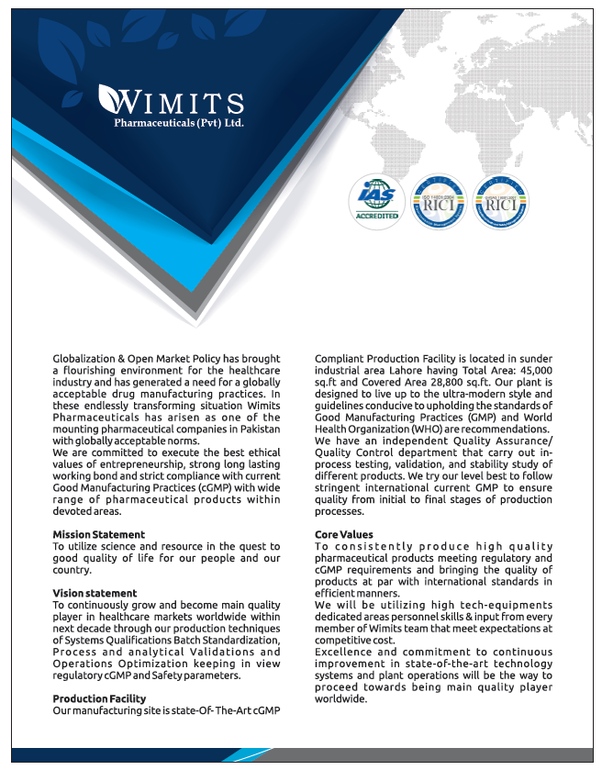

ABOUT US
Name of the Manufacturer | Wimits Pharmaceuticals (Pvt.) Ltd.
Address | Plot No. 129 – Sunder Industrial Estate Raiwind Road, Lahore, Pakistan
Drug Manufacturing License No. | 000789
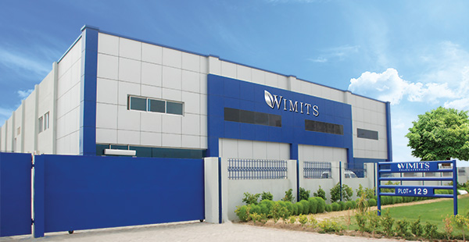
PRODUCT LIST
INJECTION SECTION
Sr. # | Reg. # | Product Name | Composition | Pack Size
1 | 078303 | Meprawits Injection | Each ml contains:  Mepyramine Maleate…. 50mg  (Wimits's Specifications) | 50ml
2 | 078304 | Sulphamit Injection | Each ml contains:  Sulphadimidine Sodium…..333.3mg  (Wimits's Specifications) | 100ml
3 | 078305 | Loxitar Injection | Each ml contains:  Meloxicam BP …………..10mg  (Wimits's Specifications) | 50ml
4 | 078306 | Trinex Injection | Each ml injection contains:  Trimethoprim BP ……….80mg  Sulfadiazine BP ……….400mg  (Wimits's Specifications) | 50ml
5 | 078307 | Oxyfast-50 Injection | Each ml contains:  Oxytetracycline HCl BP......50mg  Lignocain HCl …………….10mg  (Wimits's Specifications) | 50ml
6 | 078308 | Enrodan Injection 20% | Each ml contains:  Enrofloxacin BP ………...200mg  (Wimits's Specifications) | 50ml
7 | 078309 | Ivermex Injection | Each ml contains:  Ivermectin BP …………...10mg  (Wimits's Specifications) | 50ml
8 | 078310 | Tylomit-G Injection | Each ml contains:  Tylosin Tartrate ………...100mg  Gentamicin Sulphate ..….50mg  (Wimits's Specifications) | 100ml
9 | 088611 | Enrowim Injection | Each ml contains:  Enrofloxacin ….. 205mg  (As per innovator’s specifications) | 100ml
10 | 088612 | Fento Injection | Each ml contains:  Ketoprofen …. 100mg  (As per innovator’s Specifications) | 100ml
11 | 088613 | Wimmex Injection | Each ml contains:  Ivermectin……20mg  (BP Specifications) | 50ml
12 | 088614 | Toldimec Injection | Each ml contains:  Toldimos sodium ….. 200mg  Vitamin B12 ……….. 50mcg  (As per innovator’s specifications) | 50ml
13 | 088615 | Dora Injection | Each ml contains:  Doramectin …… 10mg  (As per innovator’s specifications) | 50ml
14 | 088616 | Loxiwim Injection | Each ml contains:  Meloxicam …… 20mg  (BP Specification) | 50ml
15 | 088617 | Oxywim Injection | Each ml contains:  Oxytetracycline as HCl …. 200mg  Lignocaine HCl …………..20mg  (As per innovator’s specifications) | 100ml
16 | 088618 | Fenkit Injection | Each ml contains:  Florfenicol ………… 300mg  (As per innovator’s specifications) | 50ml
17 | 088619 | Oxtronil Injection 34% | Each ml contains:  Nitroxynil ………. 340mg  (BP Specification) | 100ml
18 | 088620 | Kenawit Injection | Each ml contains:  Kenamycin Sulphate equivalent to Kenamycin base ………. 100mg  (As per innovator’s specifications) | 100ml
19 | 088621 | Wimflue Injection | Each ml contains:  Flunixin Meglumine …… 83mg  (USP Specifications) | 50ml
20 | 088622 | Butamak Injection | Each ml contains:  Butaphosphan ………. 100mg  Cyanocobalamin ……. 0.05mg  (As per innovator’s specifications) | 100ml

BOLUS SECTION
Sr. # | Reg. # | Product Name | Composition | Pack Size
1 | 078320 | Levacloz Bolus | Each bolus contains:  Oxyclozanide BP………..2250mg  Levamisole BP..…………1125mg  (Wimits's Specifications) | 10 x 5’s
2 | 078317 | Myquine-Bolus | Each bolus contains:  Flumequine BP .………..350mg  (Wimits's Specifications) | 10 x 5’s
3 | 078323 | Trinex-Bolus | Each bolus contains:  Trimethoprim BP……….200mg  Sulfadiazine USP……...1gm  (Wimits's Specifications) | 10 x 5’s
4 | 078319 | Fenbal-Bolus | Each bolus contains:  Fenbendazole BP…..750mg  (Wimits's Specifications) | 10 x 5’s
5 | 078321 | Levatoll-Bolus | Each bolus contains:  Levamisole HCl BP .1125mg  (Wimits's Specifications) | 10 x 5’s
6 | 078322 | Closami Bolus | Each bolus contains:  Closantel BP ……..500mg  (Wimits's Specifications) | 10 x 5’s
7 | 078325 | Albamit-600 Bolus | Each bolus contains:  Albendazole BP ...600mg  (Wimits's Specifications) | 10 x 5’s
8 | 078318 | Albamit -2500 Bolus | Each bolus contains:  Albendazole BP .....2500mg  (Wimits's Specifications) | 10 x 5’s
9 | 078324 | Albamit-152 Bolus | Each bolus contains:  Albendazole BP ....152mg  (Wimits's Specifications) | 10 x 5’s
10 | 081323 | Albamit 250 Bolus | Each bolus contains:  Albendazole BP ....250mg  (Wimits's Specifications) | 10 x 5’s

ORAL LIQUID / DRENCH SECTION
Sr. # | Reg. # | Product Name | Composition | Pack Size
1 | 078329 | Triclamex-Drench | Each ml contains:  Triclabendazol ……….50mg  Levamisol HCl BP …...37.50mg  (Wimits's Specifications) | 100ml  500ml  1000ml
2 | 078330 | Oxycloz-Drench | Each ml contains:  Oxfendazole BP ……...22.65mg  Oxyclozanide BP……..62.5mg  (Wimits's Specifications) | 100ml  500ml  1000ml
3 | 078328 | Clozasol-Drench | Each 100ml contains:  Levamisol HCl BP…...1.5gm  Oxyclozanide BP .…..3.0 gm  (Wimits's Specifications) | 100ml  500ml  1000ml
4 | 078327 | Oxamit-Drench | Each ml contains:  Oxfendazol ………….22.65mg  (Wimits's Specifications) | 100ml  500ml  1000ml
5 | 078326 | Co-Flor Liquid | Each 100ml contains:  Florfenicol (CVP) ….10gm  Colistin Sulphate ….2.5gm  (Wimits's Specifications) | 100ml  500ml  1000ml
6 | 078333 | Levamit-Drench | Each ml contains:  Levamisole HCl BP ….15mg  (Wimits's Specifications) | 100ml  500ml  1000ml
7 | 078334 | Albatop-10% Drench | Each ml contains:  Albendazole ……….100mg  (Wimits's Specifications) | 100ml  500ml  1000ml
8 | 078335 | Anthalex Drench | Each ml contains:  Albendazole BP ….100mg  Triclabendazole .....120mg  Ivermectin BP..…....2.0mg  (Wimits's Specifications) | 100ml  500ml  1000ml
9 | 078331 | Floribal Liquid | Each 100ml contains:  Florfenicol ………….23g  (Wimits's Specifications) | 100ml  500ml  1000ml
10 | 078332 | Enrolist Liquid | Each 100ml contains:  Enrofloxacin BP…..…..20gm  Colistin Sulphate BP....2.50gm  (Wimits's Specifications) | 100ml  500ml  1000ml
POWDER SECTION
Sr. # | Reg. # | Product Name | Composition | Pack Size
1 | 078311 | Colitan W.S.P | Each Gram Contains:  Clositine Sulphate ….5MIU  (Wimits's Specifications) | 100g  250g  500g  1Kg
2 | 078312 | Lancer W.S.P | Each 100gm contains:  Enrofloxacin ………..10gm  Colistin Sulphate..….4.50gm  Amantadine HCl…….5.00gm  (Wimits's Specifications) | 100g  250g  500g  1Kg
3 | 078313 | Trigger W.S.P | Each Gram Contains:  Doxycycline Hyclate……...250mg  Tylosin Tartrate BP .……..200mg  (Wimits's Specifications) | 100g  250g  500g  1Kg
4 | 078315 | Tycoon-D W.S.P | Each Gram contains:  Doxycycline Hyclate …….200mg  Colistin Sulphate .……….25mg  Tylosin Tartrate .………..100mg  Bromhexine HCl ………..5mg | 100g  250g  500g  1Kg
5 | 078314 | Striker W.S.P | Each 1000gm contains:  Chlortetracyclin HCl …..80gm  Colistin Sulphate .……..4.00gm  Neomycin Sulphate …...70.00gm  (Wimits's Specifications) | 100g  250g  500g  1Kg
6 | 078316 | Antamits W.S.P | Each Gram contains:  Amantadine HCl BP…..100mg  (Wimits's Specifications) | 100g  250g  500g  1Kg
7 | 084932 | Neorex W.S.P | Each gm contains:  Neomycin Sulphate…..720mg  (USP Specs) | 500g  1 Kg  2.5 Kg  5 Kg
8 | 080152 | Metha Flush W.S.P | Each gm contains:  Calcium Pantothenate (BP)….5mg  Methenamine (BP) (Hexamethylene Tetramine)…………………….955mg  Vitamin B2 (BP)………………10mg  Nicotinamide (BP)…………….25mg | 100g  250g  500g  1 Kg  2.5 Kg
9 | 080151 | Diarrolex W.S.P | Each gm contains:  Neomycin Sulphate (B.P)……….33.33mg  Streptomycin Sulphate (B.P)……33.33mg  Sulphaguanidine (BP)……….…333.33mg  Kaolin (USP)……………………333.33mg  Pectin (USP)……………………..33.33mg  Bismuth Sub nitrate (USP).……166.66mg  Vitamin A Acetate (BP)………….2.291mg | 12g  250g  500g  1 Kg
Share your feedback with us!!

Head Office: Suite No.3, 2nd Floor, Abrar Business Center, 25 Main Wahdat Road, Lahore, Pakistan
Plant Operations: Plot No. 129 – Sunder Industrial Estate Raiwind Road, Lahore, Pakistan
UAN: +92-42-111-11-6366
Website: www.wimits.com | Email: export@wimits.com

